|  |  |  |  |  |
| --- | --- | --- | --- | --- |
|  |  | | |  |
|  |  | | |  |
|  | Rear Seat Controls Lockout  <<Feature>>  (F003110) | | |  |
|  |  | | |  |
| Document Type | **Feature Document (FD)** | | |  |
| Template Version | **6.1b** | | |  |
| SysML Report Template Version | **O Beta (2021/06/01)** | | |  |
| Document ID | **feature_doc_rscl.docx** | | |  |
| Document Location |  | | |  |
| Document Owner | **Martin Hirschmann** | | |  |
| Document Revision | **FD0** | | |  |
| Document Status | **Draft** | | |  |
| Date Issued | **2021/06/04** | | |  |
| Date Revised | **2021/06/04** | | |  |
| Document Classification | GIS1 Item Number: | **27.60/35** | |  |
| GIS2 Classification: | **Confidential** | |
|  | | | | |
|  | | | | |
| Document Approval | | | | |
| Person | Role | | Email Confirmation | Date |
|  |  | |  |  |
|  |  | |  |  |

**Auto-Generated by MagicDraw**

Printed Copies Are Uncontrolled

# Disclaimer

**This document contains Ford Motor Company Confidential information. Disclosure of the information contained in any portion of this document is not permitted without the expressed, written consent of a duly authorized representative of Ford Motor Company, Dearborn, Michigan, U.S.A.**

**Copyright, Ó 2021 Ford Motor Company**

This document contains information developed and accumulated by and for FORD MOTOR COMPANY. As such, it is a proprietary document, which, if disseminated to unauthorized persons, would provide others with restricted information, data, or procedures not otherwise available, exposing the FORD MOTOR COMPANY to potential harm.

Employees and suppliers having custody of this specification or authorized to use it must be cognizant of its proprietary nature and ensure that the information herein is not made available to unauthorized persons.

FORD MOTOR COMPANY reserves the right to protect this work as an unpublished copyrighted work in the event of an inadvertent or deliberate unauthorized publication. FORD MOTOR COMPANY also reserves its rights under copyright laws to protect this work as a published work.

This document or portions thereof shall not be distributed outside FORD MOTOR COMPANY without prior written consent. Refer all questions concerning disclosure to the author(s) or to any duly authorized representative of Ford Motor Company.

**Copyright** © **2021 Ford Motor Company**

# Contents

Disclaimer 2

Contents 3

1 Introduction 6

1.1 Document Purpose 6

1.2 Document Scope 6

1.3 Document Audience 6

1.3.1 Stakeholder List 6

1.4 Document Organization 7

1.4.1 Document Context 7

1.4.2 Document Structure 7

1.5 Document Conventions 8

1.5.1 Classification of Chapters 8

1.5.2 Requirements Templates 8

1.6 References 8

1.6.1 Ford Documents 8

1.6.2 External Documents and Publications 8

1.7 Glossary 9

1.7.1 Definitions 9

1.7.2 Abbreviations 9

1.7.3 Parameters / Values 9

2 Feature Overview 10

2.1 Purpose and Description of Feature 10

2.2 Feature Variants 10

2.2.1 Regions & Markets 11

2.3 Input Requirements/Documents 11

2.4 Lessons Learned 11

2.5 Assumptions 11

3 Feature Context 13

3.1 Feature Context Diagram 13

3.2 List of Influences 13

4 Feature Modeling 16

4.1 Operation Modes and States 16

4.2 Use Cases 16

4.2.1 Use Case Diagram 16

4.2.2 Actors 17

4.2.3 Use Case Descriptions 17

4.3 Driving and Operation Scenarios 21

4.4 Decision Tables 22

5 Feature Requirements 23

5.1 Functional Requirements 23

5.1.1 Error Handling 25

5.2 Non-Functional Requirements 26

5.2.1 Security 26

5.2.2 Reliability 26

5.2.3 Performance 26

5.3 HMI Requirements 26

5.4 Other Requirements 28

5.4.1 Design Requirements 28

5.4.2 Manufacturing Requirements 28

5.4.3 Service Requirements 28

5.4.4 After Sales Requirements 29

5.4.5 Process Requirements 29

5.4.6 Uncategorized Requirements 29

6 Functional Safety 31

6.1 System Behaviors for HARA 31

6.2 Functional Safety Assumptions 31

6.3 Safety Goals 32

6.4 Functional Safety Requirements 32

6.4.1 Safety Goal: SG1 SG_01: Unintended PCL deactivation shall be prevented 33

6.4.2 Safety Goal: SG2 SG_02: Ensure Power Child Lock is activated when requested 34

6.4.3 Safety Goal: SG3 SG_03: Ensure Power Child Lock is Activated when Global Lock is Enabled 36

6.4.4 Safety Goal: SG4 SG_04: Unintended Power Child Lock deactivation shall be prevented when Global Lock is Enabled 37

6.4.5 Safety Goal: SG-002028/A Prevent Hazard (Example) 38

6.4.6 Derivation of Functional Safety Requirements on Assumptions 38

6.4.7 ASIL Decomposition of Functional Safety Requirements 38

7 CyberSecurity 39

7.1 Security Goals 39

7.2 Cybersecurity Requirements 39

8 Architecture 40

8.1 Functional Decomposition 40

8.1.1 Functions 43

8.2 Logical Architecture 43

8.2.1 Logical Elements 44

8.2.2 Logical Interfaces 45

9 Traceability Matrix 46

10 Open Concerns 48

11 Revision History 49

12 Appendix 50

12.1 Definitions 50

12.2 Abbreviations 50

**List of Figures**

Figure 2: Rear Seat Controls Lockout 10

Figure 4: Context Diagram 13

Figure 5: Operation States 16

Figure 6: RSCL Use Cases 17

Figure 7: SG_01 W&RC – SG_01: Unintended PCL deactivation shall be prevented 34

Figure 7: SG02 W&RC – SG_02: Ensure Power Child Lock is activated when requested 36

Figure 7: W&RC #1 Diagram – Prevent Hazard (Example) 38

Figure 8: Operate RSCL 42

Figure 9: Logical Architecture Structure 44

**List of Tables**

Table 1: Features described in this FD 6

Table 4: Ford internal Documents 8

Table 6: External documents and publications 9

Table 8: Parameters / Values used in this document 9

Table 2: Feature Variants 11

Table 3: Regions & Markets 11

Table 2‑1: Input Requirements/Documents 11

Table 9: List of Influences 15

Table 10: Operation Modes and States on Operation States 16

Table 11: Transitions between Operation Modes and States on Operation States 16

Table 12: List of Actors 17

Table 13: System Behaviors for HARA 31

Table 14: Functional Safety Assumptions 32

Table 15: Functional Safety Goals 32

Table 18: Cybersecurity Goals 39

Table 16: List of Functions 43

Table 19: Logical Elements 45

Table 20: Open Concerns *(Not supported by MagicDraw report generation)* 48

Table 21: Definitions used in this document 50

Table 22: Abbreviations used in this document 52

# Introduction

## Document Purpose

A Feature Document (FD) document defines a Feature on [Concept Level](https://bd101001.pd2.ford.com/stages/#/workspace/209/_vv/(process/activity/_Y6ftAPI2VsW5zd82DgHb6g)). It specifies **what** the feature shall do and how it shall behave from customer perspective. It should also provide reasoning and background **why** we have the feature in the vehicle.

The FD also serves as an Item Definition as defined by ISO26262 for those features, which follow the Ford Functional Safety process. Refer [FFSG01.10 Feature Document Guideline](https://azureford.sharepoint.com/sites/GlobalFunctionalSafety/Released%20Templates%20Guidelines%20and%20Examples/Guidelines/FFSG01.10_FeatureDocument_Guideline.pdf) for how to apply the Feature Doc template for Functional Safety.

## Document Scope

This Feature Document (FD) specifies the following features:

|  |  |  |  |
| --- | --- | --- | --- |
| **Feature ID** | **Feature Name** | **Owner** | **Reference** |
| F003110 | Rear Seat Controls Lockout  (Program(s): ) | Martin Hirschmann |  |

Table 1: Features described in this FD

## Document Audience

The FD is written by the feature owner of Martin Hirschmann. All Stakeholders, i.e., all people who have a valid interest in the feature should read and, if possible, review the FD. It needs to be guaranteed, that all stakeholders have access to the currently valid version of the FD.

### Stakeholder List

For the latest list of stakeholder of the feature and their influence refer to <Put VSEM Link here>.

|  |  |  |  |  |
| --- | --- | --- | --- | --- |
| **Name** | **CDSID** | **Contact Info** | **Role** | **Stakeholder Group** |
| Al hayek, Ibaa (I.) |  |  |  |  |
| Knight, Warren (W.) | wknight2@ford.com | SV Feature Owner Dunton | Supervisor | Systems Engineer |
| Cinar, Ahmet (.) | acinar1@ford.com | PCL |  |  |
| Vellaramkalayil, Denney (D.) | dvellara@ford.com | PCL |  |  |
| Williams, Bruce (B.) | bwilli28@ford.com | Senior Core Electrical Architect |  |  |
| Ahmed, Hanan (H.) | hahmed6@ford.com | IVIC Basic Design RSCL |  |  |
| Ricks, John |  | Core Body Module SW / SV |  |  |
| Chekanov, Anton (A.) | achekano@ford.com | MBSE Modeller | Model Architect | Systems Engineer |
| Reed, Greg (G.) | greed29@ford.com | URC Feature Owner |  |  |
| Paquette, Robert (R.J.) | rpaquet2@ford.com | Audio FNA |  |  |
| Hirschmann, Martin (M.H.) | mhirschm@ford.com | Feature Owner | Feature Owner | Systems Engineer |
| Steinman, Andrew (A.) | asteinm3@ford.com | Functional Systems Architect |  |  |
| Struthers, Alec (A.) | astruthe@ford.com | HMI Supervisor (CIED) | Supervisor |  |
| Sabri, Ahmad (A.) | asabri3@ford.com | Core Body Module SW / SV |  |  |
| Goyal, Abhishek (A.) | agoyal11@ford.com | RSD Lead (CIED) |  |  |
| Syed, Raheel (R.) | rsyed6@ford.com | HMI switch lead (CIED) |  |  |
| Trombly, Dennis (D.) |  |  |  |  |
| Gutowski, Alan (A.) |  |  |  |  |
| Hillebrand, Georg (G.) | ghilleb2@ford.com | SV MBSE | Supervisor | Systems Engineer |
| Bogachuk, Marija (M.) | mbogachu@ford.com | Systems Engineer VCSE |  |  |
| van Auken, Chris (C.) |  |  |  |  |

## Document Organization

### Document Context

Refer to the [Specification Structure page](http://wiki.ford.com/display/RequirementsEngineering/Specification+templates) in the [Ford RE Wiki](http://wiki.ford.com/display/RequirementsEngineering/Requirements+Engineering+for+SW+Enabled+Features) to understand how the FD relates to other Ford Requirements Documents and Specifications.

### Document Structure

The structure of this document is explained below:

Fehler! Verweisquelle konnte nicht gefunden werden. – Explains how to use this document including responsibilities and requisite documents. Explains the terminology. Gives a clarification of the definitions, concepts and abbreviations used in the document.

Fehler! Verweisquelle konnte nicht gefunden werden. – States briefly the background and the purpose of the feature, feature variants and corresponding regions and markets. Also includes input requirements, assumptions and constraints.

Fehler! Verweisquelle konnte nicht gefunden werden. – describes all external entities, which have an influence on the feature.

Fehler! Verweisquelle konnte nicht gefunden werden. – Contains Use Case, Driving Scenarios, State Charts to describe the functional behavior of the feature.

**Feature Requirements** – Lists functional and non-functional requirements of the feature.

**Functional Safety** – Lists System Behaviors, Safety Goals and Safety Requirements of the feature.

Fehler! Verweisquelle konnte nicht gefunden werden. – Lists Security Goals and Security Requirements of the feature.

Fehler! Verweisquelle konnte nicht gefunden werden. – Shows the coarse architecture, which the feature requirements are deployed to. Describes the elements and the boundary of the feature as well as the decomposition and distribution of associated functions.

**Traceability Matrix** – Traceability Matrix.

Fehler! Verweisquelle konnte nicht gefunden werden. – List of Open Concerns

Fehler! Verweisquelle konnte nicht gefunden werden. – Document Change History including a list of new or modified requirements. The requirements in this document are tagged, and this section contains different types of tables listing all, new, or changed requirements by their title and page no.

Fehler! Verweisquelle konnte nicht gefunden werden. – Appendix

## Document Conventions

### Classification of Chapters

A chapter is considered mandatory, unless the chapter or its parent chapter(s) are categorized by using the tag:

**#Classification:** Some Condition

If no requirement/other content is known for a mandatory chapter, leave a statement “Not Applicable”

Some chapters have a follow certain rules in context of specific Ford processes, e.g. Functional Safety. This is indicated at the beginning of the corresponding chapter by the tags:

**#Functional Safety:** Some process specific explanation

**#Cybersecurity:** Some process specific explanation

### Requirements Templates

Refer to “[How to use the Specification Templates](http://wiki.ford.com/display/RequirementsEngineering/How+to+use+the+Specification+Templates?src=contextnavpagetreemode)” on how to use the specification templates and the VBA macros to create/edit the requirements in the specifications.

#### **Requirements Attributes**

The templates provided by *Specification_Macros.dotm* define a list of attributes for each requirement. This helps to classify the requirement. The attributes are explained at [RE Wiki - Requirements Attributes](http://wiki.ford.com/display/RequirementsEngineering/Requirements+Attributes?src=contextnavpagetreemode).

## References

### Ford Documents

List here all Ford internal documents, which are directly related to the feature.

| **Reference** | **Title** | **Doc. ID** | **Document Location** | **Revision** |
| --- | --- | --- | --- | --- |
|  | FS F000187 Power Child Lock (PCL) |  |  |  |
|  | ConOps Rear Seat Controls Lockout |  |  |  |
|  | Power Child Lock |  |  |  |
|  | Ford GIS Standard |  |  |  |

Table 2: Ford internal Documents

### External Documents and Publications

The list of external documents could include books, reports and online sources.

| **Reference** | **Document / Publication** | **Document Location** |
| --- | --- | --- |
| IEEE Std 1012-2004 IEEE Standard for Software Verification and Validation |  |  |
| ISO/IEC 19500-2:2003 | Information technology -- Open Distributed Processing -- Part 2 |  |
| UML Testing Profile (UTP), v1.2 |  |  |
| Wikipedia |  |  |

Table 3: External documents and publications

## Glossary

See Appendix for Definitions and Abbreviations.

### Definitions

### Abbreviations

### Parameters / Values

| **Name** | **Description** | **Range / Resolution** |
| --- | --- | --- |

Table 4: Parameters / Values used in this document

# Feature Overview

## Purpose and Description of Feature

The new Rear Seat Controls Lockout feature shall enable removal of the physical lockout buttons from the driver door switch pack and allow the customer to engage / disengage the controls listed below using Center Stack HMI. The Center Stack HMI would allow the rear seat controls to be either locked / unlocked individually or all at once (global). The list of rear seat controls contained in this feature is as follows:

- Rear door inner handles

- Rear window switches

- Rear audio controls through rear control panel and/or URC

- Rear climate controls through rear control panel and/or URC

- Chauffeur mode

- URC lockout

NOTE: Global Rear Seat Controls Lockout will always engage / disengage all RSCL features together.

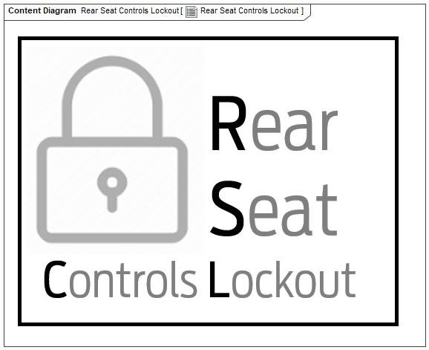

Figure 1: Rear Seat Controls Lockout

## Feature Variants

|  |  |  |
| --- | --- | --- |
| **Variant Name** | **Variant Description** | **Remarks** |
| **Variant 1** |  |  |

Table 5: Feature Variants

### Regions & Markets

|  |  |  |  |  |  |  |
| --- | --- | --- | --- | --- | --- | --- |
| **Market /**  **Region**  Variant Name | **North America** | **South America** | **Europe** | **Middle East/Africa** | **Asia / Pacific** | **China** |
| **Variant 1** | Optional | Optional | Optional | Optional | Optional | Optional |

Table 6: Regions & Markets

## Input Requirements/Documents

|  |  |  |  |
| --- | --- | --- | --- |
| **Reference**  (Reference as listed in ch. “**Fehler! Verweisquelle konnte nicht gefunden werden.**”) | **Section/Requirement** | **Description** | **Derived Requirement**  (optional – reference to requirement in ch. “**Fehler! Verweisquelle konnte nicht gefunden werden.**”) |
| **Attribute Requirements** | | | |
|  | <Placeholder AR> |  |  |
| **Ford Engineering Standards** | | | |
|  | <Example: some SDS (requirement)> |  |  |
| **Legal Regulations** | | | |
|  | Window Child Lock symbol Reference to ergonomics and ASO | The symbol shall comply to ergonomics and ASO reauirements |  |
|  | Power Child Lock symbol Reference to ergonomics and ASO | The symbol shall comply to ergonomics and ASO requirements |  |
|  | Compliance with FMVSS101 | The Feature shall comply with FMVSS101. |  |
| **Industry Standards** | | | |
|  | ISO 26262 | The system should be developed according to Ford's implementation of Functional Safety. |  |
| **Other Sources** | | | |
|  | RQT-011411-013585 Power Child Lock | SDS PCL |  |

Table 2‑7: Input Requirements/Documents

## Lessons Learned

No lessons learned specified.

## Assumptions

Assumption1

To get the full feature content, the electrical architecture of the program must support the following:

- HMI: Support of softbuttons

- Power Child Lock: PCL capable rear door latches (e.g. hardwired conventional latches or E-latches).

Cyber Security required for E-Latches. (PCL rated ASIL A, respective signals rated C2 )

- Window Child Lock: window lockout capable rear window switches (e.g. “DCU-controlled one touch up” on rear windows)

- Rear Audio Lock: rear audio lockout capable rear audio panel (e.g. RACM)

- Rear Climate Lock: rear climate lockout capable rear climate panel (e.g. RHVAC or RACM)

The following build combinations will be supported:

|  |  |  |
| --- | --- | --- |
| **Build Combination** | **Variant Description** | **Remarks** |
| **1** | PCL = No  WCL = Yes  RAL = Yes  RCL = Yes  RAL & RCL triggered only by URC |  |
| **2** | PCL = Yes  WCL = Yes  RAL = Yes  RCL = Yes  RAL & RCL triggered only by URC |  |
| **3** | PCL = No  WCL = Yes  RAL = Yes  RCL = Yes  RAL & RCL triggered by URC and RACM |  |
| **4** | PCL = Yes  WCL = Yes  RAL = Yes  RCL = Yes  RAL & RCL triggered by URC and RACM |  |
| **5** | PCL = No  WCL = Yes  RAL = Yes  RCL = Yes  RAL & RCL triggered by URC and VSP |  |
| **6** | PCL = Yes  WCL = Yes  RAL = Yes  RCL = Yes  RAL & RCL triggered by URC and VSP |  |
| **7** | PCL = Yes  WCL = don't care  RAL = No  RCL = No  Refer to F00187 Power Child Lock |  |

|  |
| --- |
| **Purpose** |
|  |

# Feature Context

## Feature Context Diagram

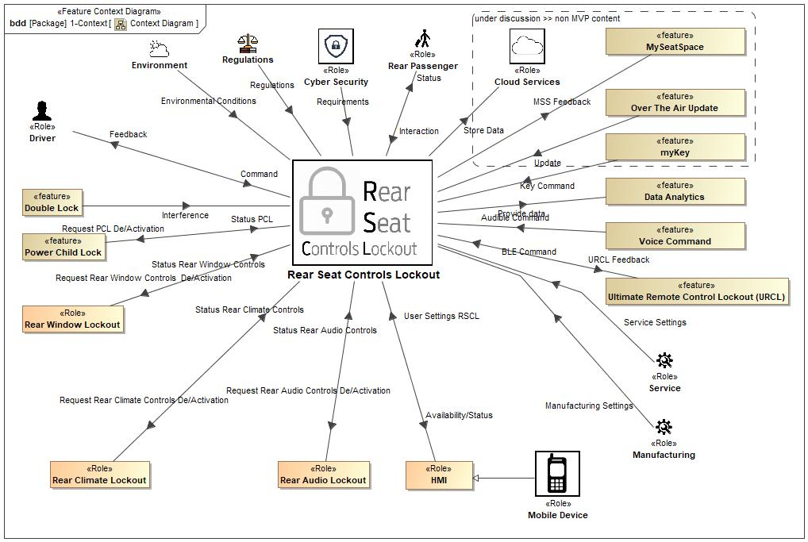

Figure 2: Context Diagram

## List of Influences

|  |  |  |
| --- | --- | --- |
| **ID** | **External Entity** | **Influence Description** |
| Audible Command | Voice Command To Rear Seat Controls Lockout | Driver request for feature status through voice command |
| Availability/Status | Rear Seat Controls Lockout To HMI | Status of RSCL feature |
| BLE Command | Ultimate Remote Control Lockout (URCL) To Rear Seat Controls Lockout | Enable / Disable mobile user to change feature setting |
| Command | Driver To Rear Seat Controls Lockout | Driver request for feature status |
| Environmental Conditions | Environment To Rear Seat Controls Lockout | Environmental conditions must not change status of feature |
| Feedback | Rear Seat Controls Lockout To Driver | Status of RSCL feature to driver |
| Interaction | Rear Passenger To Rear Seat Controls Lockout | Can interact with the interior door handle, window switch, all rear audio and climate adjuster including URC through rear mobile devices. |
| Interference | Double Lock To Rear Seat Controls Lockout | Action of DL and RSCL on rear inner handle must follow defined rules. |
| Key Command | myKey To Rear Seat Controls Lockout | Request feature settings dependent on used key |
| Manufacturing Settings | Manufacturing To Rear Seat Controls Lockout | Manufacturing can switch on / off feature. |
| MSS Feedback | Rear Seat Controls Lockout To MySeatSpace | Enable / Disable passenger to change feature settings through mobile device or RSE/VSP |
| Provide data | Rear Seat Controls Lockout To Data Analytics | Enable Data analytics based on provided signals |
| Regulations | Regulations To Rear Seat Controls Lockout | Feature must fulfill all applicable regulations. |
| Request PCL De/Activation | Rear Seat Controls Lockout To Power Child Lock | Enable / Disable passenger from using rear inner door handle |
| Request Rear Audio Controls De/Activation | Rear Seat Controls Lockout To Rear Audio Lockout | Enable / Disable passenger from using rear audio controls |
| Request Rear Climate Controls De/Activation | Rear Seat Controls Lockout To Rear Climate Lockout | Enable / Disable passenger from using rear climate controls |
| Request Rear Window Controls De/Activation | Rear Seat Controls Lockout To Rear Window Lockout | Enable / disable rear passenger from using rear window switch |
| Requirements | Cyber Security To Rear Seat Controls Lockout | Feature shall fulfill Cyber Security requirements through ECUs. |
| Service Settings | Service To Rear Seat Controls Lockout | Service can switch on / off feature |
| Status | Rear Seat Controls Lockout To Rear Passenger | Enable / Disable rear customer from using rear seat controls |
| Status PCL | Power Child Lock To Rear Seat Controls Lockout | Provide status of PCL |
| Status Rear Audio Controls | Rear Audio Lockout To Rear Seat Controls Lockout | Provide status of RAL |
| Status Rear Climate Controls | Rear Climate Lockout To Rear Seat Controls Lockout | Provide status of RCL |
| Status Rear Window Controls | Rear Window Lockout To Rear Seat Controls Lockout | Provide status of RWL |
| Store Data | Rear Seat Controls Lockout To Cloud Services | Store data for Data Analytics |
| Update | Over The Air Update To Rear Seat Controls Lockout | Update feature content / cure issues through OTA |
| URCL Feedback | Rear Seat Controls Lockout To Ultimate Remote Control Lockout (URCL) | Enable / Disable mobile user to change feature settings |
| User Settings RSCL | HMI To Rear Seat Controls Lockout | Arbitrate request for feature status change |

Table 8: List of Influences

# Feature Modeling

## Operation Modes and States

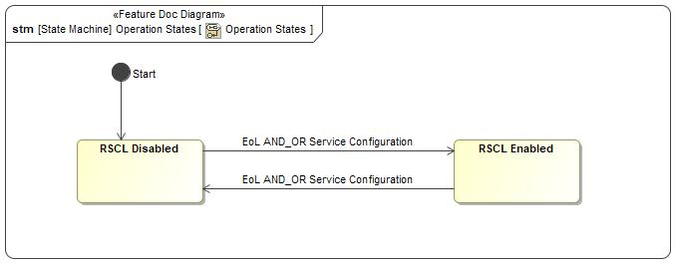

Figure 3: Operation States

|  |  |  |
| --- | --- | --- |
| **State** | **Description** | **Requirements Reference** (optional) |
| RSCL Disabled | Feature not available to customer. |  |
| RSCL Enabled | Feature available to customer. |  |

Table 9: Operation Modes and States on Operation States

|  |  |  |  |  |
| --- | --- | --- | --- | --- |
| **Transition ID** | **Source** | **Destination** | **Description** | **Requirements Reference**  (optional) |
| T1 | Start | RSCL Disabled |  |  |
| T2 | RSCL Disabled | RSCL Enabled | Trigger signal: EoL AND_OR Service Configuration  SignalEvent EoL AND_OR Service Configuration |  |
| T3 | RSCL Enabled | RSCL Disabled | Trigger signal: EoL AND_OR Service Configuration  SignalEvent EoL AND_OR Service Configuration |  |

Table 10: Transitions between Operation Modes and States on Operation States

## Use Cases

### Use Case Diagram

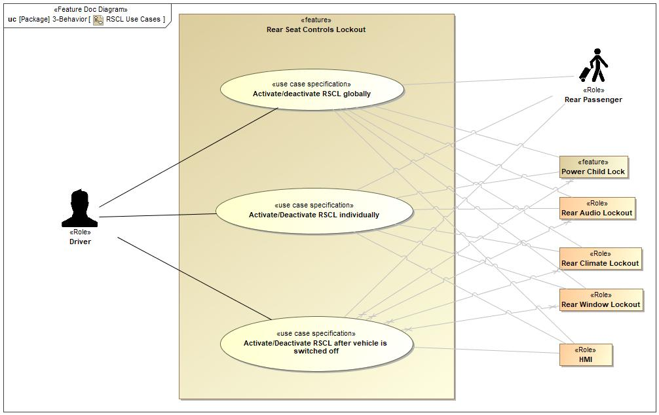

Figure 4: RSCL Use Cases

### Actors

| **Actor** | **Description** |
| --- | --- |
| Driver | Main customer requesting feature status |
| HMI | Activate / Deactivate feature settings |
| Power Child Lock | Activate / Deactivate rear door handles |
| Rear Audio Lockout | Activate / Deactivate rear audio controls |
| Rear Climate Lockout | Activate / Deactivate rear climate controls |
| Rear Passenger | Main user of rear seat controls |
| Rear Window Lockout | Activate / deactivate rear window controls |

Table 11: List of Actors

### Use Case Descriptions

Activate/deactivate RSCL globally

|  |  |  |
| --- | --- | --- |
| **Actors** | Primary | Driver |
| Secondary | Rear Passenger |
| Secondary | Power Child Lock |
| Secondary | Rear Audio Lockout |
| Secondary | Rear Climate Lockout |
| Secondary | Rear Window Lockout |
| Secondary | HMI |
| **Subject** |  | Rear Seat Controls Lockout |
| **Description** |  | The driver activates /deactivates global Rear Seat Controls Lockout feature  - PCL (Ability to open the rear doors with the rear inner door handles),  and  - WCL (Ability to change the rear window positions with the rear window switch)  and  - RAL (Ability to change the audio settings with rear audio controls)  and  - RCL (Ability to change the rear climate settings with rear climate controls)  and  - URCL (Ability to change any rear settings with rear linked mobile devices) |
| **Preconditions** | PreC1 | · The vehicle is in accessory mode or above (BEV: ready to drive mode)  · SYNC is booted (up to 30s after first wake-up trigger)  · SYNC screen is active.  · The vehicle can be stationary or in motion  Driver distraction requirements (ASO) determine the maximum number of steps allowed in the SYNC menu while the vehicle is in motion.  · Rear Seat Controls Lockout feature is set in the last state before SYNC was shut off  · SYNC / IPC indicates to driver PCL status by permanently visible sign when activated |
| **Main Flow** | M1 | Driver uses the SYNC HMI to change the global Rear Seat Controls Lockout setting. |
| M2 | Based on the driver requests the Rear Seat Controls Lockout feature enables/disables  - PCL  (interaction with F000186 Double Lock refer to F000187 Power Child Lock)  and  - WCL  and  - RAL  and  - RCL  and  - URCL |
| M3 | HMI / IPC highlights to the driver that PCL is activated by permanently visible sign. |
| M4 | Rear window switch LEDs (search light) turn out if WCL is activated. |
| **Postconditions** | PostC1 | The rear passenger can or can’t  - open the rear doors with the rear inner door handles  and  - change the rear window position with the rear window switch  and  - change the audio setting with the rear audio controls  and  - Change the rear climate settings with the rear climate controls  and  - Change any rear settings with the rear linked mobile devices |

Activate/Deactivate RSCL individually

|  |  |  |
| --- | --- | --- |
| **Actors** | Primary | Driver |
| Secondary | Rear Passenger |
| Secondary | Rear Climate Lockout |
| Secondary | HMI |
| Secondary | Power Child Lock |
| Secondary | Rear Audio Lockout |
| Secondary | Rear Window Lockout |
| **Subject** |  | Rear Seat Controls Lockout |
| **Description** |  | The driver activates /deactivates the following Rear Seat Controls Lockout features individually to disable/enable  - PCL (Ability to open the rear doors with the rear inner door handles),  and/or  - WCL (Ability to change the rear window positions with the rear window switch)  and/or  - RAL (Ability to change the audio settings with rear audio controls)  and/or  - RCL (Ability to change the rear climate settings with rear climate controls)  and/or  - URCL (Ability to change any rear settings with rear linked mobile devices) |
| **Preconditions** | PreC1 | · The vehicle is in accessory mode or above (BEV: ready to drive mode)  · SYNC is booted (up to 30s after first wake-up trigger)  · SYNC screen is active.  · The vehicle can be stationary or in motion  Driver distraction requirements (ASO) determine the maximum number of steps allowed in the SYNC menu while the vehicle is in motion.  · Rear Seat Controls Lockout feature is set in the last state before SYNC was shut off  · SYNC / IPC indicates to driver PCL status by permanently visible sign when activated |
| **Main Flow** | M1 | Driver uses the SYNC HMI to change the Rear Seat Controls Lockout settings individually. |
| M2 | Based on the driver requests the corresponding Rear Seat Controls Lockout feature enables/disables  - PCL  (interaction with F000186 Double Lock refer to F000187 Power Child Lock)  and/or  - WCL  and/or  - RAL  and/or  - RCL  and/or  - URCL |
| M3 | HMI / IPC highlights to the driver if PCL is activated by permanently visible sign. |
| M4 | Rear window switch LEDs (search light) turn out if WCL is activated |
| **Postconditions** | PostC1 | Based on the driver’s requested Rear Seat Controls Lockout feature settings  the rear passenger can or can’t  - open the rear doors with the rear inner door handles  - and/or  - change the rear window position with the rear window switch  and/or  - change the audio setting with the rear audio controls  and/or  - Change the rear climate settings with the rear climate controls  and/or  - Change any rear settings with the rear linked mobile devices |

Activate/Deactivate RSCL after vehicle is switched off

|  |  |  |
| --- | --- | --- |
| **Actors** | Primary | Driver |
| Secondary | Rear Passenger |
| Secondary | Rear Audio Lockout |
| Secondary | Rear Climate Lockout |
| Secondary | Rear Window Lockout |
| Secondary | Power Child Lock |
| Secondary | HMI |
| **Subject** |  | Rear Seat Controls Lockout |
| **Description** |  | Driver stops the vehicle and turns engine off. SYNC will be active until Delayed Accessory timer times out or driver opens the driver door. Driver can activate / deactivate all Rear Seat Controls globally and individually until SYNC shuts down for one of a.m. reasons. |
| **Preconditions** | PreC1 | Engine off, ignition off, SYNC active, RSCL follows Delayed Accessory timer. |
| **Main Flow** | M1 | Driver switches engine and ignition off but leaves driver door closed. |
| M2 | Driver changes settings of rear seat controls to on or off |
| M3 | Rear seat controls lockout feature activates / deactivates   * rear door handles / switches (if supported) * rear window switches (if supported) * rear audio panel (if supported) * rear climate panel (if supported) * URC (if supported)   accordingly. |
| **Alternative Flow Steps** | A1 | AF1.1 Driver switches engine and ignition off and opens the driver door  AF1.2 Sync immediately shuts down  AF1.3 Driver cannot change settings |
| **Postconditions** | PostC1 | Settings according latest driver input before SYNC shut down. |

## Driving and Operation Scenarios

Driving and Operation Scenarios

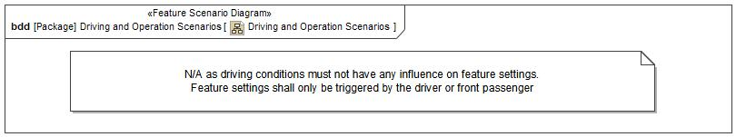

## Decision Tables

*Not supported by MagicDraw report generation.*

# Feature Requirements

## Functional Requirements

R_F_RSCL_2 PCL Behavior in Crash

If PCL is supported and If a crash occurs / is detected, RSCL shall not change the state of PCL.

That means,

• if PCL is activated, it shall prevent the appropriate PCL doors from being opened via interior door handle

• if PCL is deactivated, it shall not prevent the appropriate PCL doors from being opened via interior door handle.

|  |  |  |  |  |  |  |  |
| --- | --- | --- | --- | --- | --- | --- | --- |
| Requirement ID: R_F_RSCL_2 | | | | | | | |
| **Rationale** |  | | | | | | |
| **Acceptance Criteria** |  | | | | | | |
| **Notes** |  | | | | | | |
| **Source** | FD-PCL | | | | | **Owner** | M.Hirschmann (MHIRSCHM) |
| **Source Req.** |  | | | | | **V&V Method** |  |
| **Type** | Functional | | | **Priority** | 2 - Medium | **Status** | In-Progress |
| [Req. Template](http://wiki.ford.com/display/RequirementsEngineering/Requirements+Attributes) Version | | 6.0 | End of Requirement | | | | |

R_F_RSCL_3 Interdependency with Double Lock

If PCL is supported and already active, a Double Lock deactivation shall have no impact on lock status of Child Locked Doors.

|  |  |  |  |  |  |  |  |
| --- | --- | --- | --- | --- | --- | --- | --- |
| Requirement ID: R_F_RSCL_3 | | | | | | | |
| **Rationale** |  | | | | | | |
| **Acceptance Criteria** |  | | | | | | |
| **Notes** |  | | | | | | |
| **Source** | FD-PCL | | | | | **Owner** | M.Hirschmann (MHIRSCHM) |
| **Source Req.** |  | | | | | **V&V Method** |  |
| **Type** | Functional | | | **Priority** | 2 - Medium | **Status** | In-Progress |
| [Req. Template](http://wiki.ford.com/display/RequirementsEngineering/Requirements+Attributes) Version | | 6.0 | End of Requirement | | | | |

R_F_RSCL_4 Inhibit PCL Activation/Deactivation in Double Lock

If PCLis supported and vehicle is double-locked, RSCL shall ignore any driver request to activate / deactivate PCL

|  |  |  |  |  |  |  |  |
| --- | --- | --- | --- | --- | --- | --- | --- |
| Requirement ID: R_F_RSCL_4 | | | | | | | |
| **Rationale** |  | | | | | | |
| **Acceptance Criteria** |  | | | | | | |
| **Notes** |  | | | | | | |
| **Source** | FD-PCL | | | | | **Owner** | M.Hirschmann (MHIRSCHM) |
| **Source Req.** |  | | | | | **V&V Method** |  |
| **Type** | Functional | | | **Priority** | 2 - Medium | **Status** | In-Progress |
| [Req. Template](http://wiki.ford.com/display/RequirementsEngineering/Requirements+Attributes) Version | | 6.0 | End of Requirement | | | | |

R_F_RSCL_5 Exterior Door Handle in Vehicle Locked State

If

• PCL is activated AND

• the vehicle is locked, but not double-locked AND

• interior door handle of a PCL enabled door is pulled,

RSCL shall enable the corresponding exterior door handle to allow somebody from outside the vehicle to open that door.

Note:

In double-lock state an activated PCL shall have no influence on the exterior handle.

|  |  |  |  |  |  |  |  |
| --- | --- | --- | --- | --- | --- | --- | --- |
| Requirement ID: R_F_RSCL_5 | | | | | | | |
| **Rationale** |  | | | | | | |
| **Acceptance Criteria** |  | | | | | | |
| **Notes** |  | | | | | | |
| **Source** | FD-PCL | | | | | **Owner** | M.Hirschmann (MHIRSCHM) |
| **Source Req.** |  | | | | | **V&V Method** |  |
| **Type** | Functional | | | **Priority** | 2 - Medium | **Status** | In-Progress |
| [Req. Template](http://wiki.ford.com/display/RequirementsEngineering/Requirements+Attributes) Version | | 6.0 | End of Requirement | | | | |

R_F_RSCL_6 Vehicle Mode Dependency

RSCL shall work in all ignition states.

During ignition off RSCL shall work until the driver opens a door or deleayed accessory timer times out.

Settings for locking of rear climate control will not be available as soon as ignition is off.

|  |  |  |  |  |  |  |  |
| --- | --- | --- | --- | --- | --- | --- | --- |
| Requirement ID: R_F_RSCL_6 | | | | | | | |
| **Rationale** |  | | | | | | |
| **Acceptance Criteria** |  | | | | | | |
| **Notes** | RSCL shall work in all vehicle modes in which SYNC screen is active. | | | | | | |
| **Source** |  | | | | | **Owner** | M.Hirschmann (MHIRSCHM) |
| **Source Req.** |  | | | | | **V&V Method** |  |
| **Type** | Functional | | | **Priority** | 2 - Medium | **Status** | In-Progress |
| [Req. Template](http://wiki.ford.com/display/RequirementsEngineering/Requirements+Attributes) Version | | 6.0 | End of Requirement | | | | |

R_F_RSCL_23 PCL activation/deactivation

If PCL is supported and

- If user activates PCL via HMI the rear inner door handles shall be disabled,

- If user deactivates PCL via HMI the rear inner door handles shall be enabled.

|  |  |  |  |  |  |  |  |
| --- | --- | --- | --- | --- | --- | --- | --- |
| Requirement ID: R_F_RSCL_23 | | | | | | | |
| **Rationale** |  | | | | | | |
| **Acceptance Criteria** |  | | | | | | |
| **Notes** |  | | | | | | |
| **Source** |  | | | | | **Owner** | M.Hirschmann (MHIRSCHM) |
| **Source Req.** |  | | | | | **V&V Method** |  |
| **Type** | Functional | | | **Priority** | 2 - Medium | **Status** | In-Progress |
| [Req. Template](http://wiki.ford.com/display/RequirementsEngineering/Requirements+Attributes) Version | | 6.0 | End of Requirement | | | | |

R_F_RSCL_24 WCL activation/deactivation

If WCL is supported and

- If user activates WCL via HMI the rear window switches shall be disabled,

- If user deactivates WCL via HMI the rear window switches shall be enabled

|  |  |  |  |  |  |  |  |
| --- | --- | --- | --- | --- | --- | --- | --- |
| Requirement ID: R_F_RSCL_24 | | | | | | | |
| **Rationale** |  | | | | | | |
| **Acceptance Criteria** |  | | | | | | |
| **Notes** |  | | | | | | |
| **Source** |  | | | | | **Owner** | M.Hirschmann (MHIRSCHM) |
| **Source Req.** |  | | | | | **V&V Method** |  |
| **Type** | Functional | | | **Priority** | 2 - Medium | **Status** | In-Progress |
| [Req. Template](http://wiki.ford.com/display/RequirementsEngineering/Requirements+Attributes) Version | | 6.0 | End of Requirement | | | | |

R_F_RSCL_25 RAL activation/deactivation

If RAL is supported and

- If user activates RAL via HMI the rear audio controls shall be disabled,

- If user deactivates RAL via HMI the rear audio controls shall be enabled

|  |  |  |  |  |  |  |  |
| --- | --- | --- | --- | --- | --- | --- | --- |
| Requirement ID: R_F_RSCL_25 | | | | | | | |
| **Rationale** |  | | | | | | |
| **Acceptance Criteria** |  | | | | | | |
| **Notes** |  | | | | | | |
| **Source** |  | | | | | **Owner** | M.Hirschmann (MHIRSCHM) |
| **Source Req.** |  | | | | | **V&V Method** |  |
| **Type** | Functional | | | **Priority** | 2 - Medium | **Status** | In-Progress |
| [Req. Template](http://wiki.ford.com/display/RequirementsEngineering/Requirements+Attributes) Version | | 6.0 | End of Requirement | | | | |

R_F_RSCL_26 RCL activation/deactivation

If RCL is supported and

- If user activates RCL via HMI the rear climate controls shall be disabled,

- If user deactivates RCL via HMI the rear climate controls shall be enabled

|  |  |  |  |  |  |  |  |
| --- | --- | --- | --- | --- | --- | --- | --- |
| Requirement ID: R_F_RSCL_26 | | | | | | | |
| **Rationale** |  | | | | | | |
| **Acceptance Criteria** |  | | | | | | |
| **Notes** |  | | | | | | |
| **Source** |  | | | | | **Owner** | M.Hirschmann (MHIRSCHM) |
| **Source Req.** |  | | | | | **V&V Method** |  |
| **Type** | Functional | | | **Priority** | 2 - Medium | **Status** | In-Progress |
| [Req. Template](http://wiki.ford.com/display/RequirementsEngineering/Requirements+Attributes) Version | | 6.0 | End of Requirement | | | | |

R_F_RSCL_27 URCL activation/deactivation

If URCL is supported and

- If user activates URCL via HMI the linked hand-held devices shall be disabled,

- If user deactivates URCL via HMI the linked hand-held devices shall be enabled

|  |  |  |  |  |  |  |  |
| --- | --- | --- | --- | --- | --- | --- | --- |
| Requirement ID: R_F_RSCL_27 | | | | | | | |
| **Rationale** |  | | | | | | |
| **Acceptance Criteria** |  | | | | | | |
| **Notes** |  | | | | | | |
| **Source** |  | | | | | **Owner** | M.Hirschmann (MHIRSCHM) |
| **Source Req.** |  | | | | | **V&V Method** |  |
| **Type** | Functional | | | **Priority** | 2 - Medium | **Status** | In-Progress |
| [Req. Template](http://wiki.ford.com/display/RequirementsEngineering/Requirements+Attributes) Version | | 6.0 | End of Requirement | | | | |

### Error Handling

R_F_RSCL_7 Error Message to User

If an error is detected, RSCL shall indicate an error to the user for all supported functionalities:

- PCL (if supported)

- WCL (if supported)

- RAL (if supported)

- RCL (if supported)

- URCL (if supported)

|  |  |  |  |  |  |  |  |
| --- | --- | --- | --- | --- | --- | --- | --- |
| Requirement ID: R_F_RSCL_7 | | | | | | | |
| **Rationale** | Aid user in case of faults | | | | | | |
| **Acceptance Criteria** |  | | | | | | |
| **Notes** |  | | | | | | |
| **Source** |  | | | | | **Owner** | M.Hirschmann (MHIRSCHM) |
| **Source Req.** |  | | | | | **V&V Method** |  |
| **Type** | Error Handling | | | **Priority** | 2 - Medium | **Status** | In-Progress |
| [Req. Template](http://wiki.ford.com/display/RequirementsEngineering/Requirements+Attributes) Version | | 6.0 | End of Requirement | | | | |

R_F_RSCL_8 PCL State Mismatch

If PCL is supported, RSCL shall detect an error, if a mismatch between the user requested activation state and the (actual) activation state of the doors persists for longer than TPclErrorTPclError shall be tunable in the range of 0..30 sec. Default is 3 sec.

|  |  |  |  |  |  |  |  |
| --- | --- | --- | --- | --- | --- | --- | --- |
| Requirement ID: R_F_RSCL_8 | | | | | | | |
| **Rationale** |  | | | | | | |
| **Acceptance Criteria** |  | | | | | | |
| **Notes** |  | | | | | | |
| **Source** | FD-PCL | | | | | **Owner** | M.Hirschmann (MHIRSCHM) |
| **Source Req.** |  | | | | | **V&V Method** |  |
| **Type** | Error Handling | | | **Priority** | 2 - Medium | **Status** | In-Progress |
| [Req. Template](http://wiki.ford.com/display/RequirementsEngineering/Requirements+Attributes) Version | | 6.0 | End of Requirement | | | | |

R_F_RSCL_10 PCL Error Detection

RSCL shall detect feature related errors for:

- PCL (if supported)

- WCL (if supported)

- RAL (if supported)

- RCL (if supported)

- URCL (if supported)

|  |  |  |  |  |  |  |  |
| --- | --- | --- | --- | --- | --- | --- | --- |
| Requirement ID: R_F_RSCL_10 | | | | | | | |
| **Rationale** |  | | | | | | |
| **Acceptance Criteria** |  | | | | | | |
| **Notes** |  | | | | | | |
| **Source** | FD-PCL | | | | | **Owner** | M.Hirschmann (MHIRSCHM) |
| **Source Req.** |  | | | | | **V&V Method** |  |
| **Type** | Error Handling | | | **Priority** | 2 - Medium | **Status** | In-Progress |
| [Req. Template](http://wiki.ford.com/display/RequirementsEngineering/Requirements+Attributes) Version | | 6.0 | End of Requirement | | | | |

## Non-Functional Requirements

### Security

No Security Requirements specified.

### Reliability

No Reliability Requirements specified.

### Performance

No Performance Requirements specified.

## HMI Requirements

R_F_RSCL_11 Feature Settings/Activation via SYNC HMI

RSCL shall provide a user interface to allow the user to

- activate / deactivate all of the following functionalities (if supported by the vehicle) globally

• rear inner door handles

• rear window switches

• rear audio

• rear climate settings

• URCL

and,

- activate / deactivate each of the above functionalities (if supported by the vehicle) individually

via soft-buttons or voice commands.

|  |  |  |  |  |  |  |  |
| --- | --- | --- | --- | --- | --- | --- | --- |
| Requirement ID: R_F_RSCL_11 | | | | | | | |
| **Rationale** |  | | | | | | |
| **Acceptance Criteria** |  | | | | | | |
| **Notes** |  | | | | | | |
| **Source** |  | | | | | **Owner** | M.Hirschmann (MHIRSCHM) |
| **Source Req.** |  | | | | | **V&V Method** |  |
| **Type** | HMI Requirement | | | **Priority** | 2 - Medium | **Status** | In-Progress |
| [Req. Template](http://wiki.ford.com/display/RequirementsEngineering/Requirements+Attributes) Version | | 6.0 | End of Requirement | | | | |

R_F_RSCL_12 Confirmation of Activation / Deactivation Request

If PCL is supported and a user activates / deactivates PCL, RSCL shall give a visual PCL confirmation to the user within tbd msec.

|  |  |  |  |  |  |  |  |
| --- | --- | --- | --- | --- | --- | --- | --- |
| Requirement ID: R_F_RSCL_12 | | | | | | | |
| **Rationale** | User must be permanently informed about the real PCL status. | | | | | | |
| **Acceptance Criteria** |  | | | | | | |
| **Notes** |  | | | | | | |
| **Source** | FD-PCL | | | | | **Owner** | M.Hirschmann (MHIRSCHM) |
| **Source Req.** |  | | | | | **V&V Method** |  |
| **Type** | HMI Requirement | | | **Priority** | 2 - Medium | **Status** | In-Progress |
| [Req. Template](http://wiki.ford.com/display/RequirementsEngineering/Requirements+Attributes) Version | | 6.0 | End of Requirement | | | | |

R_F_RSCL_13 Use of symbols

Used Symbols for PCL and WCL shall comply to ergonomics and ASO requirements.

|  |  |  |  |  |  |  |  |
| --- | --- | --- | --- | --- | --- | --- | --- |
| Requirement ID: R_F_RSCL_13 | | | | | | | |
| **Rationale** |  | | | | | | |
| **Acceptance Criteria** |  | | | | | | |
| **Notes** |  | | | | | | |
| **Source** | ASO | | | | | **Owner** | M.Hirschmann (MHIRSCHM) |
| **Source Req.** |  | | | | | **V&V Method** |  |
| **Type** | HMI Requirement | | | **Priority** | 2 - Medium | **Status** | In-Progress |
| [Req. Template](http://wiki.ford.com/display/RequirementsEngineering/Requirements+Attributes) Version | | 6.0 | End of Requirement | | | | |

R_F_RSCL_14 RSCL Status Indication

RSCL shall provide a visual status indication via HMI to the user for the activation state of RSCL functionalities.

|  |  |  |  |  |  |  |  |
| --- | --- | --- | --- | --- | --- | --- | --- |
| Requirement ID: R_F_RSCL_14 | | | | | | | |
| **Rationale** | User shall be aware of current feature status at all times. | | | | | | |
| **Acceptance Criteria** |  | | | | | | |
| **Notes** |  | | | | | | |
| **Source** |  | | | | | **Owner** | M.Hirschmann (MHIRSCHM) |
| **Source Req.** |  | | | | | **V&V Method** |  |
| **Type** | HMI Requirement | | | **Priority** | 2 - Medium | **Status** | In-Progress |
| [Req. Template](http://wiki.ford.com/display/RequirementsEngineering/Requirements+Attributes) Version | | 6.0 | End of Requirement | | | | |

R_F_RSCL_16 User Notifications II

In case PCL is not available due to hardware assumptions the customers shall be informed through the SYNC screen, that the vehicle is equipped with manual child lock latches and that they must enable / disable child lock by inserting the mechanical device in the door shut face.

|  |  |  |  |  |  |  |  |
| --- | --- | --- | --- | --- | --- | --- | --- |
| Requirement ID: R_F_RSCL_16 | | | | | | | |
| **Rationale** |  | | | | | | |
| **Acceptance Criteria** |  | | | | | | |
| **Notes** |  | | | | | | |
| **Source** | Alignment with CIED | | | | | **Owner** | M.Hirschmann (MHIRSCHM) |
| **Source Req.** |  | | | | | **V&V Method** |  |
| **Type** | HMI Requirement | | | **Priority** | 2 - Medium | **Status** | In-Progress |
| [Req. Template](http://wiki.ford.com/display/RequirementsEngineering/Requirements+Attributes) Version | | 6.0 | End of Requirement | | | | |

## Other Requirements

### Design Requirements

*Not supported by MagicDraw report generation.*

### Manufacturing Requirements

R_F_RSCL_17 Enable / Disable RSCL at EOL

RSCL shall allow to enable and disable the feature in service and End-of-Line.

The supported content of the feature shall be configurable:

* PCL enable/disable
* WCL enable/disable
* RAL enable/disable
* RCL enable/disable
* URCL enable/disable

|  |  |  |  |  |  |  |  |
| --- | --- | --- | --- | --- | --- | --- | --- |
| Requirement ID: R_F_RSCL_17 | | | | | | | |
| **Rationale** | The supported content of the feature shall be configurable dependent on hardware capabilities. | | | | | | |
| **Acceptance Criteria** |  | | | | | | |
| **Notes** |  | | | | | | |
| **Source** |  | | | | | **Owner** | M.Hirschmann (MHIRSCHM) |
| **Source Req.** |  | | | | | **V&V Method** |  |
| **Type** | Other Requirement - Manufacturing | | | **Priority** | 2 - Medium | **Status** | In-Progress |
| [Req. Template](http://wiki.ford.com/display/RequirementsEngineering/Requirements+Attributes) Version | | 6.0 | End of Requirement | | | | |

### Service Requirements

R_F_RSCL_18 PCL State Mismatch DTC

If PCL is enabled and RSCL detects a state mismatch error, it shall set a diagnostic DTC for service.

|  |  |  |  |  |  |  |  |
| --- | --- | --- | --- | --- | --- | --- | --- |
| Requirement ID: R_F_RSCL_18 | | | | | | | |
| **Rationale** |  | | | | | | |
| **Acceptance Criteria** |  | | | | | | |
| **Notes** |  | | | | | | |
| **Source** | FD-PCL | | | | | **Owner** | M.Hirschmann (MHIRSCHM) |
| **Source Req.** |  | | | | | **V&V Method** |  |
| **Type** | Other Requirement - Service | | | **Priority** | 2 - Medium | **Status** | In-Progress |
| [Req. Template](http://wiki.ford.com/display/RequirementsEngineering/Requirements+Attributes) Version | | 6.0 | End of Requirement | | | | |

#### **Cloud Connectivity Data Analytics Requirements**

### After Sales Requirements

No After Sales Requirements specified.

### Process Requirements

No Process Requirements specified.

### Uncategorized Requirements

R_F_RSCL_19 Interdependency with Manual Child Lock

If PCL is supported, It shall be ensured by process or by other means, that a vehicle is equipped with either Power Child Lock or Manual Child Lock System – but not both.

|  |  |  |  |  |  |  |  |
| --- | --- | --- | --- | --- | --- | --- | --- |
| Requirement ID: R_F_RSCL_19 | | | | | | | |
| **Rationale** |  | | | | | | |
| **Acceptance Criteria** |  | | | | | | |
| **Notes** |  | | | | | | |
| **Source** | FD-PCL | | | | | **Owner** | M.Hirschmann (MHIRSCHM) |
| **Source Req.** |  | | | | | **V&V Method** |  |
| **Type** | Functional | | | **Priority** | 2 - Medium | **Status** | In-Progress |
| [Req. Template](http://wiki.ford.com/display/RequirementsEngineering/Requirements+Attributes) Version | | 6.0 | End of Requirement | | | | |

R_F_RSCL_20 Vehicle Typ Limitations

PCL shall not be available in M2 class vehicles.

|  |  |  |  |  |  |  |  |
| --- | --- | --- | --- | --- | --- | --- | --- |
| Requirement ID: R_F_RSCL_20 | | | | | | | |
| **Rationale** |  | | | | | | |
| **Acceptance Criteria** |  | | | | | | |
| **Notes** |  | | | | | | |
| **Source** | FD-PCL | | | | | **Owner** | M.Hirschmann (MHIRSCHM) |
| **Source Req.** |  | | | | | **V&V Method** |  |
| **Type** | Functional | | | **Priority** | 2 - Medium | **Status** | In-Progress |
| [Req. Template](http://wiki.ford.com/display/RequirementsEngineering/Requirements+Attributes) Version | | 6.0 | End of Requirement | | | | |

R_F_RSCL_21 Feature Enabling Conditions

If feature is enabled, it shall be available in accessory mode or above (BEV: ready to drive mode) in the last state before HMI was shut off.

HMI shall be available in up to 30s after first wake-up trigger (e.g. door open).

|  |  |  |  |  |  |  |  |
| --- | --- | --- | --- | --- | --- | --- | --- |
| Requirement ID: R_F_RSCL_21 | | | | | | | |
| **Rationale** |  | | | | | | |
| **Acceptance Criteria** |  | | | | | | |
| **Notes** |  | | | | | | |
| **Source** |  | | | | | **Owner** | M.Hirschmann (MHIRSCHM) |
| **Source Req.** |  | | | | | **V&V Method** |  |
| **Type** |  | | | **Priority** | 2 - Medium | **Status** | In-Progress |
| [Req. Template](http://wiki.ford.com/display/RequirementsEngineering/Requirements+Attributes) Version | | 6.0 | End of Requirement | | | | |

R_F_RSCL_22 PCL Hardware

If Power Child Lock is supported PCL capable latches (e.g. hardwired conventional latches or E-latches) are required

|  |  |  |  |  |  |  |  |
| --- | --- | --- | --- | --- | --- | --- | --- |
| Requirement ID: R_F_RSCL_22 | | | | | | | |
| **Rationale** |  | | | | | | |
| **Acceptance Criteria** |  | | | | | | |
| **Notes** |  | | | | | | |
| **Source** |  | | | | | **Owner** | M.Hirschmann (MHIRSCHM) |
| **Source Req.** |  | | | | | **V&V Method** |  |
| **Type** |  | | | **Priority** | 2 - Medium | **Status** | In-Progress |
| [Req. Template](http://wiki.ford.com/display/RequirementsEngineering/Requirements+Attributes) Version | | 6.0 | End of Requirement | | | | |

# Functional Safety

## System Behaviors for HARA

|  |  |  |
| --- | --- | --- |
| **ID** | **Name** | **Description** |
|  | SB10 Disable Global Lock | All supported lockable functionalities will be unlocked. |
|  | SB06 Disable Rear Audio Lock | Lockable rear audio functionalities will be unlocked. |
|  | SB02 Disable Power Child Lock | Rear inner door handles will be enabled. |
|  | SB08 Diable Rear Climate Lock | Lockable rear climate functionalities will be unlocked. |
|  | SB09 Enable Global Lock | All supported lockable functionalities will be locked. |
|  | SB12 Disable Ultimare Remote Control Lock | Rear linked hand held devices will be enabled. |
|  | SB01 Enable Power Child Lock | Rear inner door handles will be disabled. |
|  | SB05 Enable Rear Audio Lock | Lockable rear audio functionalities will be locked. |
|  | SB07 Enable Rear Climate Lock | Lockable rear climate functionalities will be locked. |
|  | SB04 Disable Rear Window Lock | Rear window switches will be enabled. |
|  | SB11 Enable Ultimare Remote Control Lock | Rear linked hand held devices will be disabled. |
|  | SB03 Enable Rear Window Lock | Rear window switches will be disabled. |

Table 12: System Behaviors for HARA

## Functional Safety Assumptions

|  |  |  |
| --- | --- | --- |
| ID | Assumption | |
|  | **Name** | Rear Passenger is in a physical condition to leave the vehicle |
| **Description** | Rear Passenger is capable to leave the Vehicle on purpose. |
| **Purpose** | Rear Passenger intends to leave the vehicle. |
| **Category** | Behavioral |
| **Related Requirement IDs** |  |
|  | **Name** | Rear Passenger is in a physical condition to open door when vehicle is stationary or driving with low speed |
| **Description** | Rear Passenger is able to open the door and could harm other traffic participants. |
| **Purpose** | Rear Passenger is physically able to open door and could harm other traffic participants that are passing by the vehicle. |
| **Category** | Behavioral |
| **Related Requirement IDs** |  |
|  | **Name** | Climate Temperatures |
| **Description** | The minimum temperature the control dial can be set to is approx. 15C and the maximum temperature the control dial can be set to is approx. 30C. |
| **Purpose** | The purpose of this Assumption is for the minimum and maximum temperature (in degrees Celsius) of the rear climate system. |
| **Category** | Behavioral |
| **Related Requirement IDs** |  |

Table 13: Functional Safety Assumptions

## Safety Goals

|  |  |  |  |  |
| --- | --- | --- | --- | --- |
| ID | Goal | | | |
| **SG1** | **Goal Name** | SG_01: Unintended PCL deactivation shall be prevented | | |
| **Description** | An unintended deactivation of child safety locks shall be prevented. Child Lock Status shall be maintained and driver shall be informed/warned about PCL Status. | | |
| **Safety Goal Concept** | Safety Goal Concept:  Warning & Recovery Concept: | | |
| **ASIL** | A | **FTTI** |  |
| **Related FSR IDs** |  | | |
| **SG2** | **Goal Name** | SG_02: Ensure Power Child Lock is activated when requested | | |
| **Description** | Child safety locks shall be activated when requested by driver. Driver shall be informed/warned about PCL Status. | | |
| **Safety Goal Concept** | Safety Goal Concept:  Warning & Recovery Concept: | | |
| **ASIL** | A | **FTTI** |  |
| **Related FSR IDs** |  | | |
| **SG3** | **Goal Name** | SG_03: Ensure Power Child Lock is Activated when Global Lock is Enabled | | |
| **Description** | Power Child Lock shall be activated when Global Lock is enabled. | | |
| **Safety Goal Concept** | Safety Goal Concept: | | |
| **ASIL** | A | **FTTI** |  |
| **Related FSR IDs** |  | | |
| **SG4** | **Goal Name** | SG_04: Unintended Power Child Lock deactivation shall be prevented when Global Lock is Enabled | | |
| **Description** | Power Child Lock deactivation shall be prevented when Global Lock is enabled. | | |
| **Safety Goal Concept** | Safety Goal Concept: | | |
| **ASIL** | A | **FTTI** |  |
| **Related FSR IDs** |  | | |
| **SG-002028/A** | **Goal Name** | Prevent Hazard (Example) | | |
| **Description** |  | | |
| **Safety Goal Concept** | Warning & Recovery Concept: | | |
| **ASIL** |  | **FTTI** |  |
| **Related FSR IDs** |  | | |

Table 14: Functional Safety Goals

## Functional Safety Requirements

### Safety Goal: SG1 SG_01: Unintended PCL deactivation shall be prevented

**Name:** SG_01: Unintended PCL deactivation shall be prevented

**Purpose:** Preventing an unintended deactivation of PCL provides driver greater control of rear door while increasing controllability that rear doors remain closed and exposure to hazard is reduced.

**Text:** An unintended deactivation of child safety locks shall be prevented. Child Lock Status shall be maintained and driver shall be informed/warned about PCL Status.

**ASIL:** A

#### Safety Goal Concept

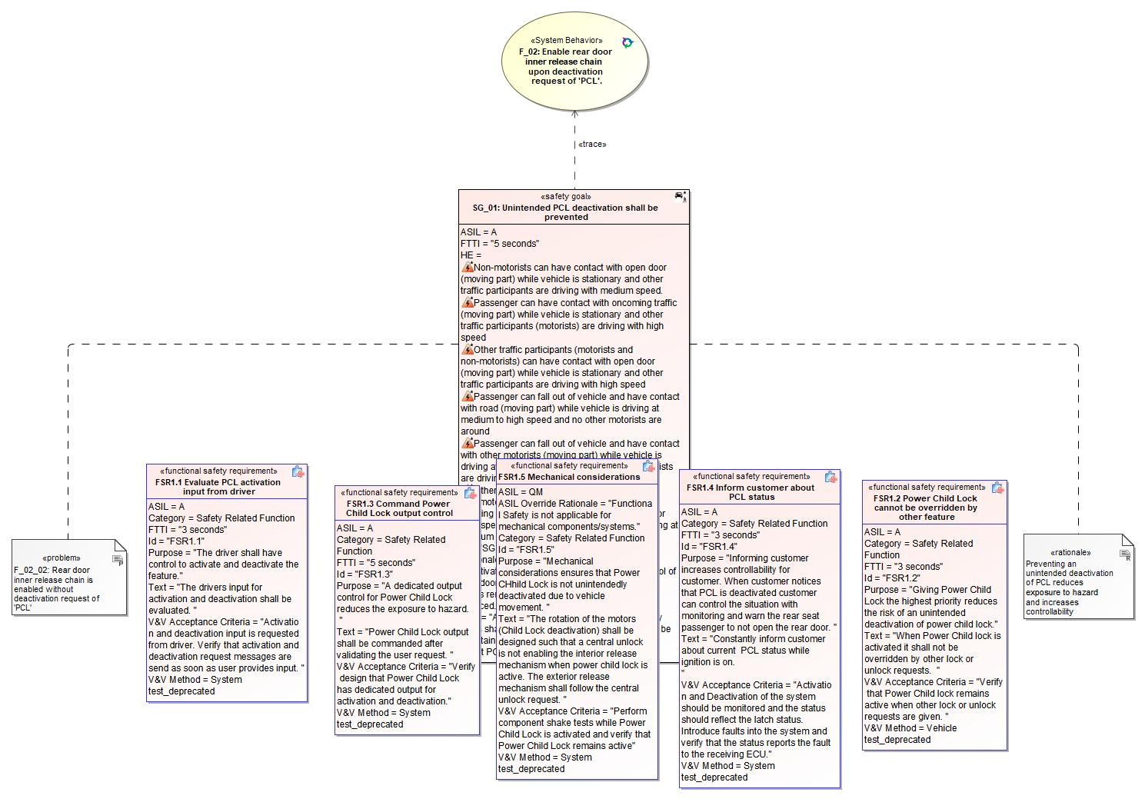

Figure 1: SG_01 Concept – SG_01: Unintended PCL deactivation shall be prevented

*Note: The authoritative source for the Safety Goals is document “FFSD 02 Hazard Analysis* *and Risk Assessment”. The documentation of Safety Goals in this chapter (In the Argumentation for Safety Goal achievement) is for information purposes only.*

*The authoritative source for the Functional Safety Requirements is section 2.1.x.3: of this document. The documentation of Functional Safety Requirements in the following chapter (complete or summarised) is for information purposes only.*

#### Warning and Recovery Concept

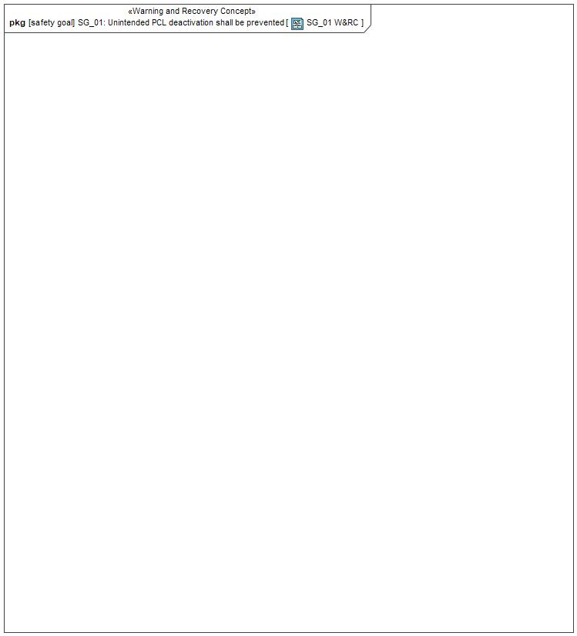

Figure 5: SG_01 W&RC – SG_01: Unintended PCL deactivation shall be prevented

### Safety Goal: SG2 SG_02: Ensure Power Child Lock is activated when requested

**Name:** SG_02: Ensure Power Child Lock is activated when requested

**Purpose:** Ensuring activation of PCL when requested provides driver greater control of exposure to hazard

**Text:** Child safety locks shall be activated when requested by driver. Driver shall be informed/warned about PCL Status.

**ASIL:** A

#### Safety Goal Concept

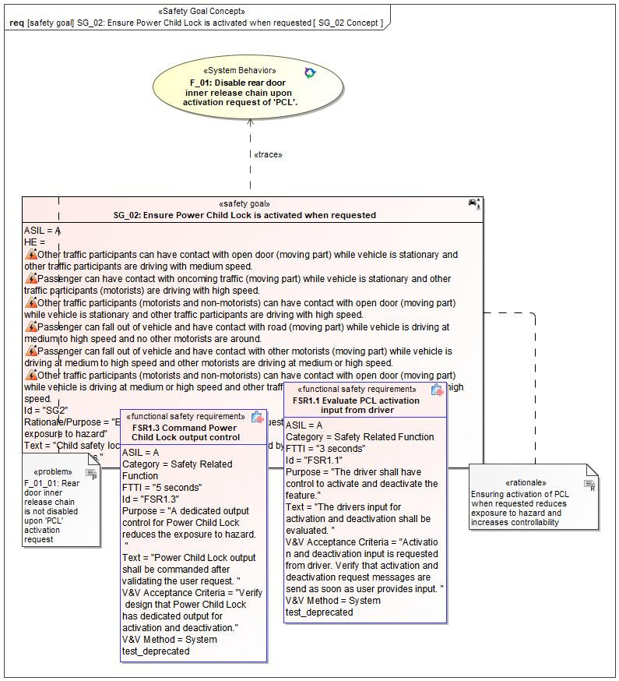

Figure 1: SG_02 Concept – SG_02: Ensure Power Child Lock is activated when requested

*Note: The authoritative source for the Safety Goals is document “FFSD 02 Hazard Analysis* *and Risk Assessment”. The documentation of Safety Goals in this chapter (In the Argumentation for Safety Goal achievement) is for information purposes only.*

*The authoritative source for the Functional Safety Requirements is section 2.1.x.3: of this document. The documentation of Functional Safety Requirements in the following chapter (complete or summarised) is for information purposes only.*

#### Warning and Recovery Concept

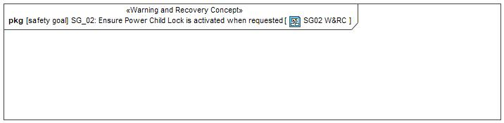

Figure 6: SG02 W&RC – SG_02: Ensure Power Child Lock is activated when requested

### Safety Goal: SG3 SG_03: Ensure Power Child Lock is Activated when Global Lock is Enabled

**Name:** SG_03: Ensure Power Child Lock is Activated when Global Lock is Enabled

**Purpose:** Enabling Global Lock also enables Power Child Lock. Ensuring PCL during a Global Locking event mitigates the risk of a rear seat occupant coming into contact with moving parts or other vehicles when exiting the vehicle.

**Text:** Power Child Lock shall be activated when Global Lock is enabled.

**ASIL:** A

#### Safety Goal Concept

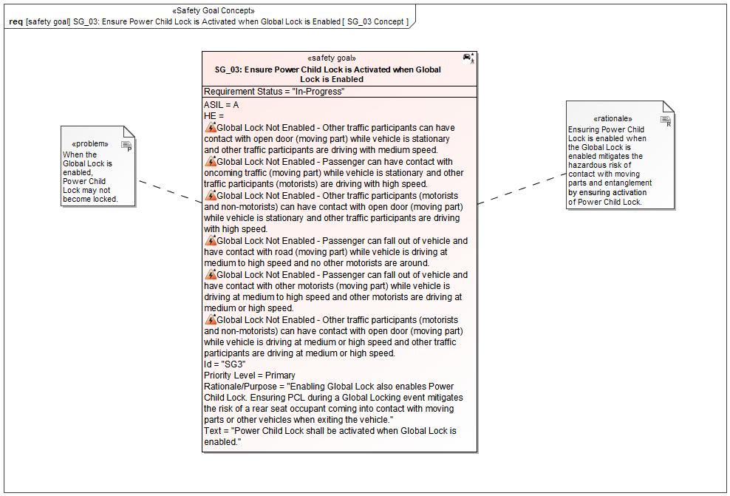

Figure 1: SG_03 Concept – SG_03: Ensure Power Child Lock is Activated when Global Lock is Enabled

*Note: The authoritative source for the Safety Goals is document “FFSD 02 Hazard Analysis* *and Risk Assessment”. The documentation of Safety Goals in this chapter (In the Argumentation for Safety Goal achievement) is for information purposes only.*

*The authoritative source for the Functional Safety Requirements is section 2.1.x.3: of this document. The documentation of Functional Safety Requirements in the following chapter (complete or summarised) is for information purposes only.*

#### Warning and Recovery Concept

No Warning and Recovery Concept diagram specified.

### Safety Goal: SG4 SG_04: Unintended Power Child Lock deactivation shall be prevented when Global Lock is Enabled

**Name:** SG_04: Unintended Power Child Lock deactivation shall be prevented when Global Lock is Enabled

**Purpose:** Preventing Power Child Lock deactivation unintendedly when a Global Locking event occurs will mitigate the risk of a rear seat occupant coming into contact with moving parts or other vehicles by increasing the controllability that the rear doors remain closed.

**Text:** Power Child Lock deactivation shall be prevented when Global Lock is enabled.

**ASIL:** A

#### Safety Goal Concept

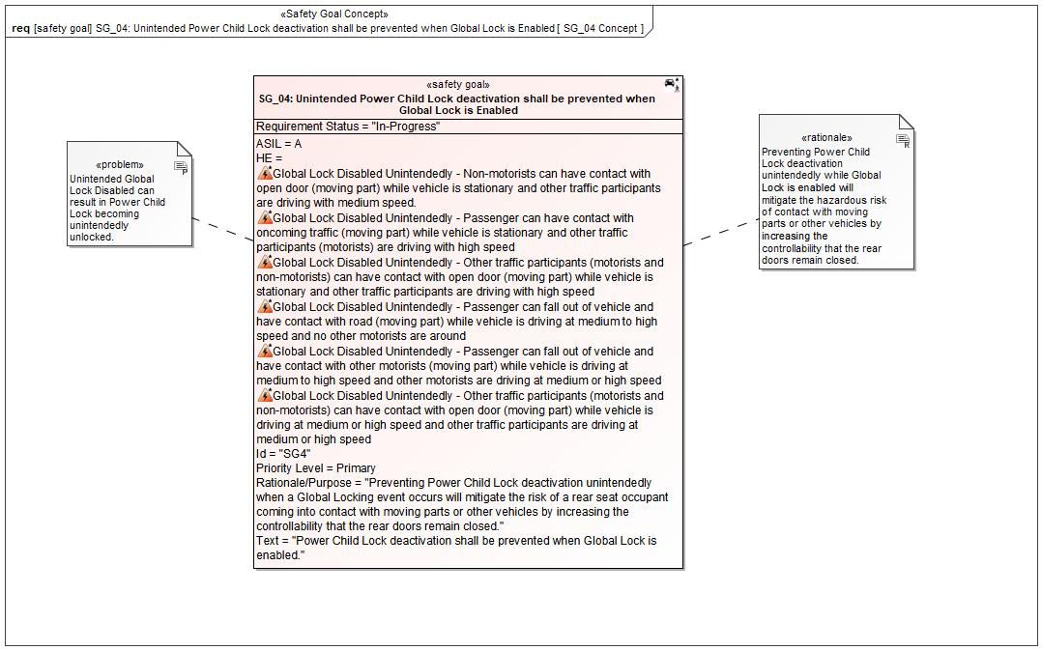

Figure 1: SG_04 Concept – SG_04: Unintended Power Child Lock deactivation shall be prevented when Global Lock is Enabled

*Note: The authoritative source for the Safety Goals is document “FFSD 02 Hazard Analysis* *and Risk Assessment”. The documentation of Safety Goals in this chapter (In the Argumentation for Safety Goal achievement) is for information purposes only.*

*The authoritative source for the Functional Safety Requirements is section 2.1.x.3: of this document. The documentation of Functional Safety Requirements in the following chapter (complete or summarised) is for information purposes only.*

#### Warning and Recovery Concept

No Warning and Recovery Concept diagram specified.

### Safety Goal: SG-002028/A Prevent Hazard (Example)

**Name:** Prevent Hazard (Example)

**Purpose:**

**Text:**

**ASIL:**

#### Safety Goal Concept

No Safety Goal Concept diagram specified.

*Note: The authoritative source for the Safety Goals is document “FFSD 02 Hazard Analysis* *and Risk Assessment”. The documentation of Safety Goals in this chapter (In the Argumentation for Safety Goal achievement) is for information purposes only.*

*The authoritative source for the Functional Safety Requirements is section 2.1.x.3: of this document. The documentation of Functional Safety Requirements in the following chapter (complete or summarised) is for information purposes only.*

#### Warning and Recovery Concept

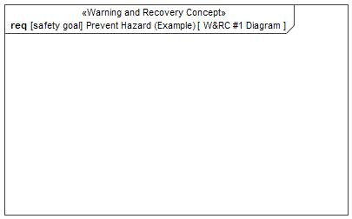

Figure 7: W&RC #1 Diagram – Prevent Hazard (Example)

### Derivation of Functional Safety Requirements on Assumptions

No Functional Safety Requirements tracing to Assumptions specified.

### ASIL Decomposition of Functional Safety Requirements

No Functional Safety Requirements with ASIL Decompositions specified.

# CyberSecurity

## Security Goals

|  |  |
| --- | --- |
| ID | Goal |

Table 15: Cybersecurity Goals

## Cybersecurity Requirements

# Architecture

## Functional Decomposition

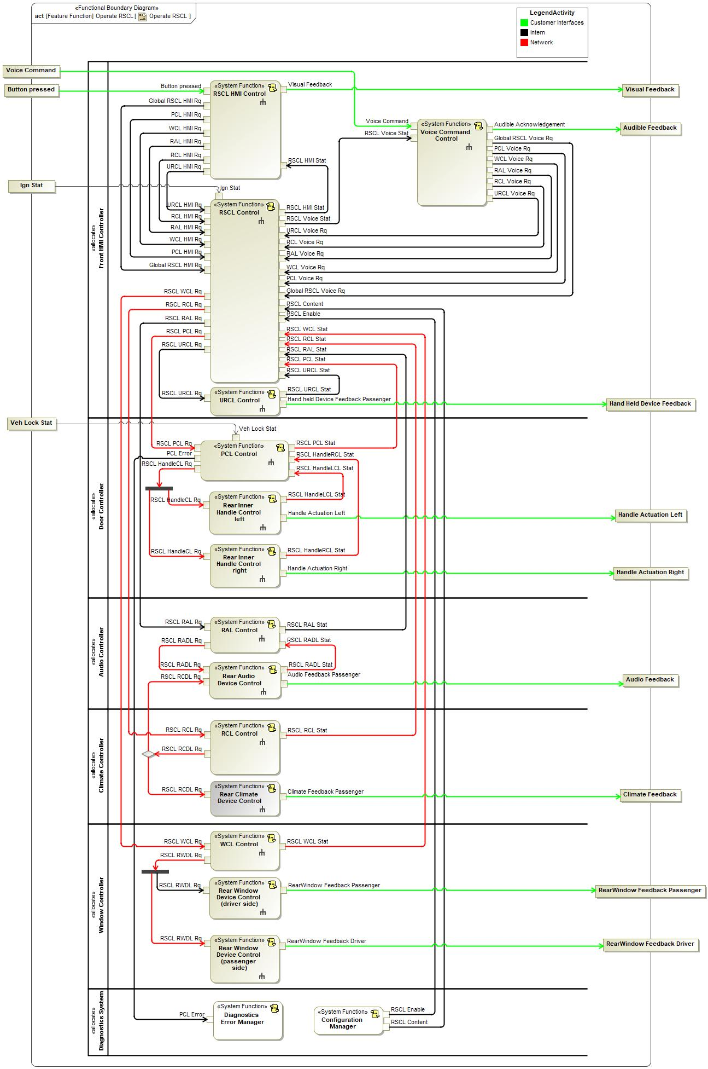

Figure 8: Operate RSCL

### Functions

| **Function Name** | Description | Comments |
| --- | --- | --- |
| *(activity)* Rear Audio Device Control | *(activity)* Read lock/unlock signal and enable / disable rear audio interfaces for rear passenger. Provide status feedback. |  |
| *(activity)* Rear Climate Device Control | *(activity)* Read lock/unlock signal and enable / disable rear climate interfaces for rear passenger. Provide status feedback |  |
| *(activity)* Configuration Manager | *(activity)* Provides vehicle configuration settings to configure feature logic or functions. |  |
| *(activity)* RCL Control | *(activity)* Controls RCL on rear climate controls  RSCL RCL status feedback |  |
| *(activity)* Rear Window Device Control (driver side) | *(activity)* Enable / Disable rear window position control interface for rear passenger. |  |
| *(activity)* PCL Control | *(activity)* Controls PCL on rear inner door handles  RSCL PCL status feedback |  |
| *(activity)* RSCL Control | *(activity)* Central state management of RSCL feature.  Reads RSCL HMI control input and provides commands / requests for PCL, WCL, RAL, RCL and URCL control. |  |
| *(activity)* Diagnostics Error Manager | *(activity)* Handles error information relevant for diagnostics. |  |
| *(activity)* Rear Window Device Control (passenger side) |  |  |
| *(activity)* Voice Command Control |  |  |
| *(activity)* Rear Inner Handle Control left | *(activity)* Controls useability of rear inner door handles.  Actual rear inner door handle status feedback. |  |
| *(activity)* RSCL HMI Control | *(activity)* Provides HMI controls for RSCL options and converts user input (e.g. physical button press) into logical signals for further processing by RSCL control.  Provides feedback to the user about feature status. |  |
| *(activity)* WCL Control | *(activity)* Controls WCL on rear window switches  RSCL WCL status feedback |  |
| *(activity)* RAL Control | *(activity)* Controls RAL on rear audio controls  RSCL RAL status feedback |  |
| *(activity)* Rear Inner Handle Control right | *(activity)* Controls useability of rear inner door handles.  Actual rear inner door handle status feedback. |  |
| *(activity)* URCL Control | *(activity)* Controls URCL on rear connected mobile devices  RSCL URC status feedback |  |

Table 16: List of Functions

## Logical Architecture

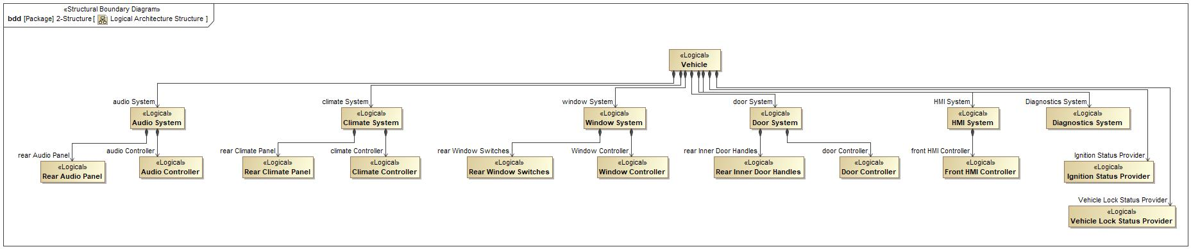

Figure 9: Logical Architecture Structure

### Logical Elements

|  |  |  |  |
| --- | --- | --- | --- |
| **Element Name** | **Description** | **Allocated Functions** | **Comments** |
|  |  |  |  |
| Audio Controller | Unit which controls the audio settings.  Lock/unlock ability to control rear audio settings by rear passenger. | * RAL Control * Rear Audio Device Control |  |
| Audio System | Sytem which contains the Audio controller and the audio interface for the rear passenger |  |  |
| Climate Controller | Unit which controlls the climate settings.  Lock/unlock ability to control rear climate settings by rear passenger. | * RCL Control * Rear Climate Device Control |  |
| Climate System | System which contains the Climate Controller and the climate interface for the rear passenger |  |  |
| Diagnostics System |  | * Diagnostics Error Manager * Configuration Manager |  |
| Door Controller | Unit which controls the door locking functionalities.  Lock/unlock ability to control rear inner door handles. | * PCL Control * Rear Inner Handle Control left * Rear Inner Handle Control right |  |
| Door System | System which contains the door controller and the rear inner door handles. |  |  |
| Front HMI Controller | Unit combining controllers for RSCL feature, HMI and URCL | * RSCL HMI Control * URCL Control * RSCL Control * Enable RSCL Settings Change * Inform Driver of RSCL Status * Voice Command Control |  |
| HMI System | System which contains all front HMIs |  |  |
| Ignition Status Provider |  | * Provide Ignition Status |  |
| Rear Audio Panel | Interface for the rear passenger to change Audio settings |  |  |
| Rear Climate Panel | Interface for the rear passenger to change Climate settings |  |  |
| Rear Inner Door Handles | Interface for the rear passenger to open the rear doors from inside |  |  |
| Rear Window Switches | Interface for the rear passenger to change the rear window positions. |  |  |
| Vehicle |  |  |  |
| Vehicle Lock Status Provider |  | * Provide Vehicle Lock Status |  |
| Window Controller | Unit which controls rear window locking functionalities. Lock/unlock ability to control rear window position with rear window switches. | * WCL Control * Rear Window Device Control (driver side) * Rear Window Device Control (passenger side) |  |
| Window System | System which contains the window controller and the window interface for the rear passenger. |  |  |

Table 17: Logical Elements

### Logical Interfaces

# Traceability Matrix

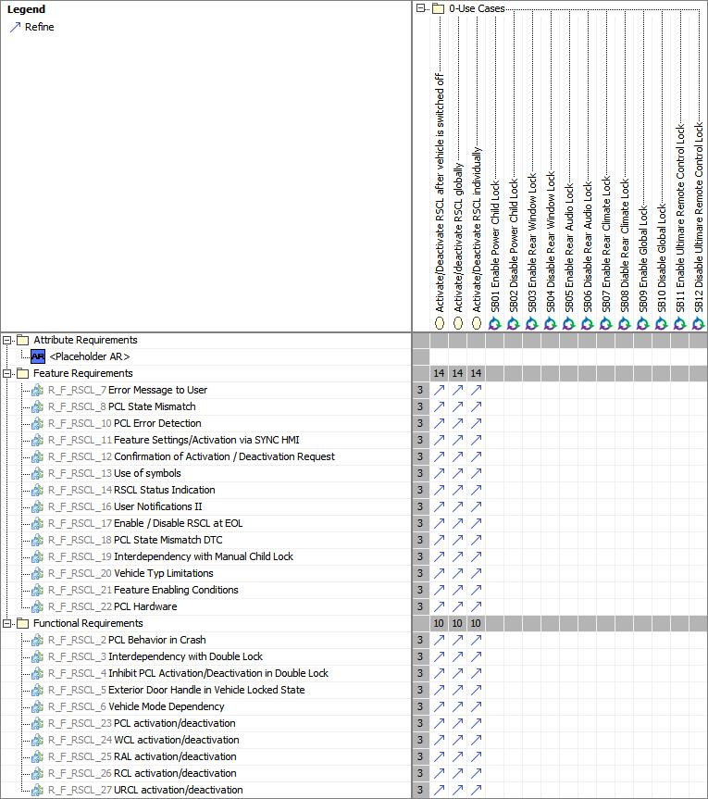

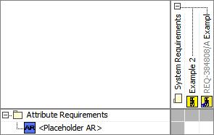

# Open Concerns

| ID | Concern Description | e-Tracker / Reference | Responsible | Status | Solution |
| --- | --- | --- | --- | --- | --- |
| 1 |  |  |  |  |  |

Table 18: Open Concerns *(Not supported by MagicDraw report generation)*

# Revision History

No Revision History found.

## Template Revisions

|  |  |  |  |  |
| --- | --- | --- | --- | --- |
| Version | Rev. | Date | Description | Responsible |
| 0 | 6 | 2015-05-26 | * Chapter “Feature Overview” and made a 2nd level heading. * Chapter “Feature Modeling” divided into 3 subchapter (“Scenarios”, “Use Cases”, “State Machines”) for different modeling methods | Jbaden1 |
| 0 | 7 | 2015-05-27 | * Table of Content updated * Template Revision History chapter added | Jbaden1 |
| 0 | 8 | 2015-07-02 | * Section “Unsettled Issues” added | Alevin7 |
| 0 | 9 | 2015-08-04 | * Section “Feature Variants” added * Section “Feature Boundary Diagram” renamed to “Feature Context Diagram” * Document Properties adapted to match needs of VBA macros | Jbaden1, Awegman1 |
| 1 | 0 | 2015-09-11 | * Section “Feature Variants” reworked * Feature Goals removed. Only “Safety Goals“ chapter remains. * Heading 2 formatting issues corrected. * Requirements / Use Cases Listing removed from traceability chapter. * Formatting of attribute table in Notation chapter corrected * Open Topics / Known Issues chapter moved to the end | Jbaden1 |
| 1 | 1 | 2015-11-16 | * Table-Styles removed (for smooth VSEM import) * Some clean-up of sections “Purpose” and “Audience” | Awegman1, jbaden1 |
| 1 | 2 | 2016-02-26 | * Minor corrections based on lessons learned from CC and PCL pilot (e.g. section market/regions) and discussion with Functional Safety Team (purpose of feature) * Footer corrected * Boundary diagram interface chapter renamed to influences. | Jbaden1 |
| 1 | 3 | 2016-02-26 | * Minor corrections after review with Whitney Keith from Functional Safety team | Jbaden1 |
| 1 | 4 | 2016-03-10 | * Some cleanup of meta-data in Word Properties | Jbaden1 |
| 1 | 5 | 2016-03-10 | * Footer formatting corrected (Issue 19) * Results from review with Functional Safety Team incorporated (Issue 20). | jbaden1 |
| 1 | 6 | 2016-04-18 | * Scenario Template added | Jbaden1 |
| 1 | 7 | 2016-04-18 | * Chapter “Operation Modes and States” moved before “Use Case” section. | Jbaden1 |
| 1 | 8 | 2016-04-18 | * Broken Wiki links repaired. | Jbaden1 |
| 2 | 0 | 2016-05-19 | * Adapted to Specification_Macros.dotm V2.0 * Requirements Templates chapter (ch. 1.7.1) no longer has an attribute table, but refers directly to the Wiki.. | Jbaden1 |
| 2 | 1 | 2016-06-10 | * Table for Context Diagram modified (lists external entities and Influence Description only) | Jbaden1 |
| 2 | 2 | 2016-07-08 | * Template version added to footer * Several hints added to the various sections * Findings from Functional Safety Team incorporated. * RE_SafetyRequirement style added | Jbaden1 |
| 2 | 3 | 2016-09-21 | * Update from Functional Safety Team incorporated (“Lessons Learned”, “System Behaviors for HARA”) | Jbaden1 |
| 2 | 4 | 2016-11-15 | * Update from Functional Safety Team incorporated (“Lessons Learned”, “System Behaviors for HARA”) * Explanatory notes made more formal | Jbaden1 |
| 3 |  |  | Skipped to synchronize with Specification_Macros.dotm |  |
| 4 |  |
| 5 | 0 | 2017-01-13 | * Meta data updated for specification macros, version 3.1 * SW Unit chapter removed for the time being * Green boxes added for user hints | Jbaden1 |
| 5 | 1 | 2017-01-18 | * Minor editorial changes | Jbaden1 |
| 6 | 0 | 2017-02-03 | * CR48: Chapter 6 renamed from “Safety” to “Functional Safety”. New sub-chapter “Safety” introduced in Non-Functional Requirements section | Jbaden1 |
| 6 | 0 | 2017-04-28 | * CR7: “RequirementsTraceability” chapter removed | Jbaden1 |
| 6 | 0 | 2017-11-15 | * CR32/53: New Cover Sheet + Disclaimer replaces FAP-150 like ones. * CR75: Some rewording -> Terminology to Glossary, Notation -> Document Conventions * CR49: Rename “Assumptions & Constraints” to “Assumptions” * CR74: Safety Assumptions added to chapter 6. * CR58: Add function allocation column to Logical Architecture chapter | Jbaden1 |
| 6 | 0 | 2018-01-31 | * CR63: Updated links to Functional Safety Sharepoint | Jbaden1 |
| 6 | 0 | 2018-07-24 | * CR69: Add FSR to FeatureDoc * CR64: Add new section "Design Requirements" to Function Spec and Feature Spec | Jbaden1 |
| 6 | 0 | 2018-08-06 | * CR53: some corrections for metada and formatting | Jbaden1 |
| 6 | 0 | 2018-09-28 | * Broken links to RE Wiki repaired | Jbaden1 |
| 6 | 0 | 2018-10-31 | * Cover sheet and footer more GIS like. Functional Safety team feedback incorporated:   + New subsections “Functional Safety Requirements, (Decomposed) FSRs and Parameters / Values   + Removal of “Logical Architecture” | Jbaden1 |
| 6 | 0 | 2018-12-12 | * FSR template removed, now as a macro in the Specification_Macros.dotm | Jbaden1 |
| 6 | 0a | 2019-05-23 | * Re-introduce “Logical Architecture” (for Functional Safety) | Jbaden1 |
| 6 | 0b | 2019-06-26 | * Chapter “Logical Elements” in “Logical Architecture” section added (FuSa CR 15136240) | Jbaden1 |
| 6 | 0c | 2019-03-22 | * Chapter “Decomposed FSRs” renamed to “ASIL Decomposition of Functional Safety Requirements” and moved beneath Chapter “Functional Safety Requirements”. Explanatory text improved. | Jbaden1 |
| 6 | 0c | 2019-04-05 | * Some wording in ASIL decomposition table modified. Description of fields in that table improved. | Jbaden1 |
| 6 | 0c | 2019-06-24 | * “Input Requirements” section modified (table approach as for the other RE templates). * “References” and “Glossary” chapter moved to the “Introduction” chapter. | Jbaden1 |
| 6 | 0c | 2019-07-02 | * "Important" box added on cover sheet which points to the macros | Jbaden1 |
| 6 | 0c | 2019-07-02 | * Subsection “Error Handling” removed form chapter “Feature Requirements”->”Functional Requirements” (teams are free to create their own substructure of that section). Note tells author not to forget about error handling. * Hint for chapter “Feature Variants” improved reworded upon request from Functional Safety Team. | Jbaden1 |
| 6 | 0c | 2019-05-11 | * Copyright notice shortened and moved to cover sheet and added to footer (to be compliant [with Ford copyright guidelines](http://www.fgti.ford.com/client/NewFGTI/CopyrightNotice.html)) * Term “Disclaimer” no longer used for what is actually only a copyright notice | Jbaden1 |
| 6 | 0c | 2019-22-11 | * Chapter “Input Requirements/Documentst: minor modifications (examples added), Word comment removed” | Jbaden1 |
| 6 | 0c | 2019-12-05 | * Upstream Documents section added to “Input Requirements/Documents” table * Custom style table formatting removed * Hint on system behaviors modified as requested from FuSa team | Jbaden1 |
| 6 | 0c | 2019-12-09 | * Term “Upstream Documents” replaced by “Attribute Requirements” in “Input Requirements/Documents” table * ASIL Decomposition table replaced by a version, which get not corrupted during VSEM import. | Jbaden1 |
| 6 | 0c | 2019-12-10 | * In ch. “Functional Safety Requirements” Word reference Id by Word reference text replaced.. | Jbaden1 |
| 6 | 1a | 2020-02-12 | * New chapter “Cybersecurity” added. | Jbaden1 |
| 6 | 1a | 2020-03-03 | * All User Hints formatted using style “RE_UserHint” to enable automatic removal by a macro. | Jbaden1 |
| 6 | 1a | 2020-03-04 | * Chapter “Cloud Connectivity Data Analytics Requirements” added upon request by D. Crockett/J. Rawlings | Jbaden1 |
| 6 | 1a | 2020-03-09 | * Missing doc property “LatestSigMappingID” and “LatestAisInterfaceID” added * doc property “CopyrightDate” re-formatted to text and copyright date field in footer corrected * Version numbering re-initialized as 0.1 * Init value of version/revision date set to “yyyy/mm/dd” instead of “yyyy-mm-dd” to be in line with the “Edit Document Property” dialog * type of document property for latest IDs changed to number instead of text | Jbaden1 |
| 6 | 1b | 2020-03-17 | * Chapter “Functional Architecture” renamed to “Functional Decomposition” * New MBSE terminology introduced: “Feature Level”, “Function Level” and “Component Level” renamed to “Concept Level”, “Logical Level” and “Technology Level” | Jbaden1 |
| 6 | 1b | 2020-07-03 | * CR31: Chapter “Traceability Matrix” added. | Jbaden1 |
| 6 | 1b | 2020-23-09 | * CR28: Alignment to [*FFSG01.10 Feature Document Guideline*](https://azureford.sharepoint.com/sites/GlobalFunctionalSafety/Released%20Templates%20Guidelines%20and%20Examples/Guidelines/FFSG01.10_FeatureDocument_Guideline.pdf) for how to apply the Feature Doc template for Functional Safety. New section “Classification of Chapters” added. “Active Tilt Control” Example in section “Logical Architecture” updated based on input from HARA training. | Jbaden1 |
| 6 | 1b | 2020-25-11 | * Reference to process definition in Stages added to “How to Use” section on cover sheet. User hints removed from “Document Purpose” chapter. * RE-Wiki links mostly replaced by Stages links, links to Functional Safety Sharepoint updated | Jbaden1 |

# Appendix

## Definitions

| **Definition** | **Description** |
| --- | --- |
| ABS_EBB | Brake Module on FD CAN |
| Door Configuration | The door configuration defines, which subset of PCL capable doors is actually PCL enabled for the Feature.  Based on body style and other factors, the door configurations shown in can be defined for PCL. |
| High speed | Approximately more than 52 mph (83 kph) |
| Low speed | Approximately 12 to 36 mph (19 to 58 kph ) |
| Medium speed | Approximately 36 mph to 52 mph (58 to 83 kph) |
| PCL enabled Door | For those vehicle doors, which have lock mechanisms capable to support PCL, the PCL functionality may be enabled or disabled by service / EoL (and optionally by the user). If for such a door PCL functionality is enabled, it is said to be a PCL enabled door. |
| term | A representation of a Concept expressed in Natural Language. In the vocabulary of a Domain of Discourse a term enables common understanding of domain concepts. |
| term glossary | A term glossary is a table of agreed upon definitions for terms used in project development that may provide clarity or avoid confusion to stakeholders. |
| Very Low Speed | Approximately 0 to 12 mph (0 to 19 kph) |

Table 19: Definitions used in this document

## Abbreviations

| **Abbr.** | **Stands for** |
| --- | --- |
| ACCM | Air Conditioning Control Module (HV compressor) |
| AGS | Active Grill Shutter - ECM_HEV |
| AHCM_PTC | Aux Heater Control Mod - PTC Heater (Gen IV) |
| Amb. Lt. Zn A | Ambient Lighting Zone A (BCM Gen 2) |
| Amb. Lt. Zn B | Ambient Lighting Zone B (BCM Gen 2) |
| APIM | Axuillary Protocol Interface Module (Sync Gen 4.2) with Cluster |
| ATCM | All Terrain Control Module |
| AWD_DLCM | All Wheel Drive Driveline Control Module |
| BCM | Body Control Module Modified Gen3 |
| BCMC_CPDB | CAN PDB |
| BCMD_IPDB | CAN PDB |
| BECM | Battery Electric Charging Module (Gen IV) |
| BISG | Belt Integrated Starter / Generator |
| BLEAM | Blue Tooth Antenna Module |
| BLEM2 | Bluetooth Low Energy Module (FNV2) |
| BMS1 | Battery Management System (BCM Gen 2) |
| BMS2 | Battery Management System (BCM Gen 2) |
| CMR_DSMC | Driver Status Monitor Camera |
| CSI | Charge Status Indicator |
| CSM 1 | Combined Sensor Module (BCM Gen 2) |
| CSM 2 | Combined Sensor Module (BCM Gen 2) |
| DCAC Inverter | DCAC Inverter (BCM Gen 2) |
| DCACA_HEV | AC to DC Converter for Power to the Box |
| DCDC_HEV | DCDC Converter (FNV2) |
| DCMR_ERAD {11} | Electric Rear Axle Drive |
| DDM | Driver Door Module |
| DDS | Driver Door Switch |
| DSM | Driver Seat Module |
| DSP | Digital Signal Processor |
| ECM_HEV {12,13} | Engine Control Module for xEV (w PT Subnet) |
| ECM_HEV {12, 13} | Engine Control Module for xEV (w PT Subnet) |
| ESCL | Electronic Steering Column Lock (BCM Gen 2) |
| FTCM | Front Trunk Release Module |
| FUS1 | Front Ultrasonic Sensor 1 |
| FUS2 | Front Ultrasonic Sensor 2 |
| FUS3 | Front Ultrasonic Sensor 3 |
| FUS4 | Front Ultrasonic Sensor 4 |
| GSM {13} | Gear Shift Module (w/ PT subnet) |
| HCM (Lvl) V | Headlamp Control Module (Leveling) |
| HVAC_RCCM | HVAC control module (standalone) |
| IPMA (ADAS) {3,4,5} | Image Processing Module A (ADAS) |
| LHM-LMP {14} | Lamp, Left Headlight Module |
| LHM-MTR {14} | Motor, Left Headlight Module |
| LRR_F | Long Range Radar - Front |
| LSM | Light Switch Module (headlamps) |
| OBCC | Off-Board Charge Controller |
| OCS | Occupant Classification Sensor (restraints) |
| PACM | Pedestrian Alert Control Module |
| PATS | Passive Anti-theft immobilizer (BCM Gen 2) |
| PCL | Power Child Lock |
| PDM | Door Module, Passenger |
| PSCM | Electric Power Assist Steering (FNV2) |
| RACM | Rear Audio Control Module A |
| RAL | Rear Audio Lock |
| RCL | Rear Climate Lock |
| RCM | Restraints Control Module (FNV3) on FD |
| RGTM (Lftgt) | Rear Gate/Trunk Module (Liftgate) |
| RHM-LMP {14} | Lamp, Right Headlight Module |
| RHM-MTR {14} | Motor, Right Headlight Module |
| RSCL | Rear Seat Contols Lockout - THIS FEATURE |
| RSE | Rear Seat Entertainment |
| RSM (FCSD) {15} | FCSD Remote Start Module |
| RSSD | Remote Seat Switch - Driver's Side |
| RTM {16} | Radio Transceiver Module |
| RUS1 | Rear Ultrasonic Sensor 1 |
| RUS2 | Rear Ultrasonic Sensor 2 |
| RUS3 | Rear Ultrasonic Sensor 3 |
| RUS4 | Rear Ultrasonic Sensor 4 |
| RVC (Rr) {1, 2} | Reverse Video Camera (BCM Gen 2) |
| SCCM | Steering Column Control Module w/ HSWM |
| SCMF | Seat Ctrl Mod F (Clim Ctrl, rear) |
| SCMG | Seat Ctrl Mod G (MultiContour Seat - Frt Drv Side) |
| SCMH | Seat Ctrl Mod H (MultiContour Seat - Frt Pass Side) |
| SCMJ_PFSM | Seat Ctrl Mod J (Power Folding Seat Module) |
| SDS | System Design Specification |
| SFWM | Smart Front Wiper Module (SCCM master) |
| SOBDMC_HPCM | Sec OBD Ctrl Mod C - HEV P/T Ctrl Mod (Gen 4) |
| SOBDM_BCCM | Sec. OBD Ctrl Mod C - Batt Chrg Ctrl Mod (Gen IV) |
| SRR_LF | Short Range Radar - Left Front |
| SRR_LR | Short Range Radar - Left Rear |
| SRR_RF | Short Range Radar - Right Front |
| SRR_RR | Short Range Radar - Right Rear |
| SUS1 | Side Ultrasonic Sensor 1 |
| SUS2 | Side Ultrasonic Sensor 2 |
| SUS3 | Side Ultrasonic Sensor 3 |
| SUS4 | Side Ultrasonic Sensor 4 |
| TCU_CPPM | Telematics Control Unit (FNV2 FD2) |
| TRM | Trailer Relay Module |
| URC | Ultimate Remote Control |
| URCL | URC-Lockout |
| VDM | Vehicle Dynamics Module |
| VSP | Vehicle Streaming Platform |
| WCL | Window Control Lock |
| WCM | Wireless Accessory Charging Module (Gen2) |
| X_HFL-LIN | Open Sesame Module |

Table 20: Abbreviations used in this document

Document ends here.